Linux Information

Options surrounded by brackets are optional

ls List all files and directories in current working directory

cd dirname Move to a new subdirectory, or “room”

**Use the name of the directory you want to move to

cd .. Move to parent directory (i.e. /Home/Pictures to /Home)

pwd Print the path of the current (working) directory

nano file1 Open a file in the text editor

Press ctrl+x to quit, follow prompts

cat file1 Display the contents of the file (no scrolling)

less file1 Display the contents of the file (allows scrolling)

Press q to quit when done

cp file1 file2 Copy file1, naming the new copy as file2

mv file1 file2 Rename file1 to file2

mv file1 dir1/ Move file1 into the directory dir1

rm file2 Delete (remove) the file named 'file2'

man rm View the manual for the 'rm' utility

mkdir dirname Create a directory with the name 'dirname'

rmdir dirname Remove the empty directory with the name 'dirname'

All of these utilities have switches to alter their functionality.

Try: ls -l

Hidden files (ones that are preceded with a period) can be viewed by using the -a tag on ls.

Try: ls -al

**Note:** Using your ls command to list files in the directory, if something is lit up in purple, it is another directory. If it’s in green, it’s a program that you can run that’s been marked as executable. If a program ends in .py, it needs the python interpreter to run. Items ending in .txt, .lst, etc. are files and you must use the less or cat commands to view them.

### **Terminus**

The Terminus game may help you get comfortable with some of these commands

<http://web.mit.edu/mprat/Public/web/Terminus/Web/main.html>

### **Encryption**

**ciphor.py --help**

Show cipher help

**ciphor.py -c 3 -e “hello world”**

Encrypt the message, hello world, with a Caesar Cipher shifting characters 3 to the left. -c designates Caesar Cipher. The 3 designates the size of the shift, and -e is encrypt (shift to the right).

**ciphor.py -k “mykey” -e “hello world”**

Encrypt the message, hello world, with a key cipher with key “mykey”. -k designates a key cipher, -e is for encrypt and “mykey” is the key used for encryption.

**ciphor.py -c 3 -d -f ciphered_message1.txt**

Decrypt the file, ciphered_message1.txt, using a Caesar Cipher and a shift of 3. -d designates decryption (shift to the left).

**ciphor.py -S -f plain_text1.txt**

Generate the signature for plain_text1.txt. -S will show the signature and -f designates an input file.

**ciphor.py -s -f ciphered_message1.txt**

Generate the letter frequencies for ciphered_message1.txt -s will show the statistics (letter frequencies) for the input text.

**ciphor.py -k “mykey” -e -f ciphered_message1.txt -o encrypted_plain_text1.txt**

Encrypt plaint_text1.txt and output the encrypted file into the file named encrypted_plain_text1.txt. -o sets the output file.

### **Password Cracking**

View the password file: **cat /etc/passwd**

View the shadow file: **sudo cat /etc/shadow**

Crack Passwords **john myshadowfile**

Show already cracked passwords **john --show shadowfile**

Specify a hash format **john --format=md5crypt shadowfile**

List the hash formats that you can specify **john --list=formats**

**All Linux Commands**

|  |  |
| --- | --- |
| **Command** | **Description** |
| cd [path]  cd  cd ..  cd ~  cd | Move into [path]  Go to home directory  Go up a directory ( . = current directory | .. = up a directory)  Move to the home directory (/home/[username])  Move to the home directory (/home/[username]) |
| ls [options] [path] | List the contents of a directory  -l table format  -a show everything (including hidden files) |
| [command1] | [command2] | Take the output of [command1] into [command2]  (Use the pipe | character) |
| pwd | Shows the complete path to the directory you’re in |
| chmod +x [filename] | Make [filename] an executable (runnable) |
| cat [path] | Display the contents of the file |
| less | Shows a little bit of the command output or file |
| man [file/command] | Show how to use a [file/command] |
| mv [/path/to/oldFile] [/path/to/newFile] | Moves [oldFile] into [newFile path] |
| mkdir [name]  rmdir [name] | Make a directory with a [name]  Delete the directory with the [name] |
| touch [filename] | Creates an empty file called [filename] |
| ps -aux | Show the processes currently running |
| xxd [binaryfile] | Shows the binary of the [binaryfile]  *Also shows ansi* |
| cp [/path/to/oldFile] [/path/to/newFile] | Moves [/path/to/oldFile] to [/path/to/newFile] |
| md5sum [file] | Shows the md5 hash of [file] |
| rm [file] | Deletes [file] |
| python3  python3 [filename] | Starts you in the python environment (>>)  Runs [filename] with python3 |
| ssh [uname]@[ipaddr] | Remote connect to a system with the username [uname] at the IP [ipaddr] |
| grep [option] [patters] [file]    Ex.  grep -E “(ht|f)tp” *.txt  Ex.  grep -E “[0-9][0-9]” *.txt    Ex.  grep -P “\d\d-\d\d\d” *.txt | Search for [word] in the directory  . any character  ? repeat 0 or 1 times  * repeat 0 or many times  + repeat 1 or many times  [a-dh] match any characters listed (a, d, or h)  \d finds any number  \w finds any word  \s find any space characters (needs -P [option])  Looks for http or ftp  () = group, | = or  Look for 2 numbers between 0 and 9  Look for 2 numbers, a hyphen, then 3 numbers |
| sudo adduser [use rname] | Add a user with the [user name]  *Ignore room number and everything else* |
| sudo deluser [user name] | Delete the user with the [user name] |
| su [user]  su root | Switch to the [user]  Switch to the root user |
| sudo apt update | Update the system |
| sudo apt install [package] | Install a [package] on the system |
| john [file] | Crack the [file] |
| john --wordlist=[wordlist] [file] | Crack the password in the [file] with the list of words in [wordlist]  Ex.  [wordlist] = /usr/share/john/password.lst |
| john --show [file] | Show the already cracked password for the [file] |
| john --format=[format] [file] | Crack the password in the [file] with [format]  Ex.  [format]=md5crypt |
| john --list=formats | List formats you can use as a [format] |
| ciphor.py  ciphor.py --help  ciphor.py -c [shift] -e [message]  ciphor.py -k [key] -e [message]  ciphor.py -c [shift] -d -f [file]  ciphor.py -S -f [file]  ciphor.py -k [k] -e -f [m] -o [e] | Runs ciphor.py  -k Designates a key cipher  -c Designates a Caeser Cipher w/ a shift  -d Designates decrypt  -S Designates a signature  -f Designates an input file  -s Shows the stats (letter frequencies)  -o Designates an output file  Show ciphor help (shows above options)  Decrypts [message] with a shift of [shift]  Encrypts [message] with the [key]  Decrypt [file] with a shift of [shift]  Generate a signature for [file]  Encrypt file [m] w/ key [k] and output it to file [e] |
| rsaHex.py [options] [message]  rsaHex.py -e [exp] -n [mod] [hx]  Ex.  rsaHex.py -e 7 -n 33 2 | Runs rsaHex.py with [options] on [message]  -e exponent  -n modulus  Encrypting [hx] with a key of ([exp], [mod])  Encrypting a message of 2 w/ a key of (7, 33) |

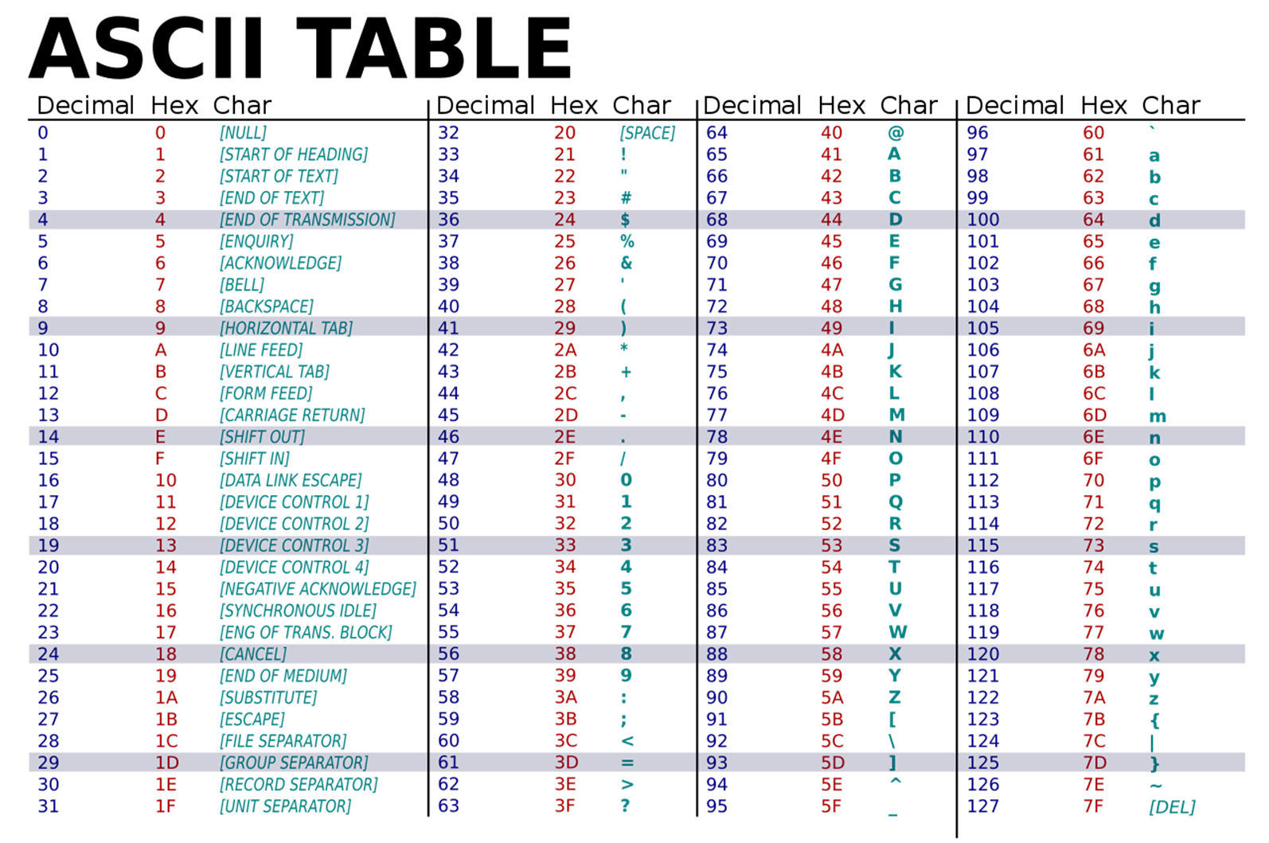

Electronics

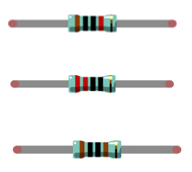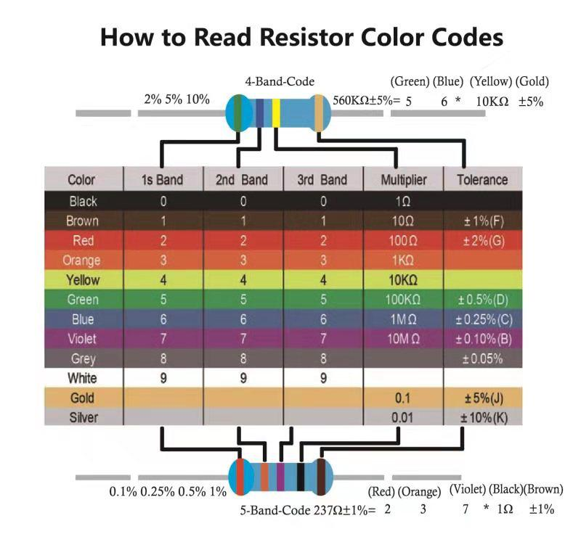

Can you determine the resistance

of the following resistors?

#### 

#### 

#### 

#### **Connecting an LED to GPIO Port 22**

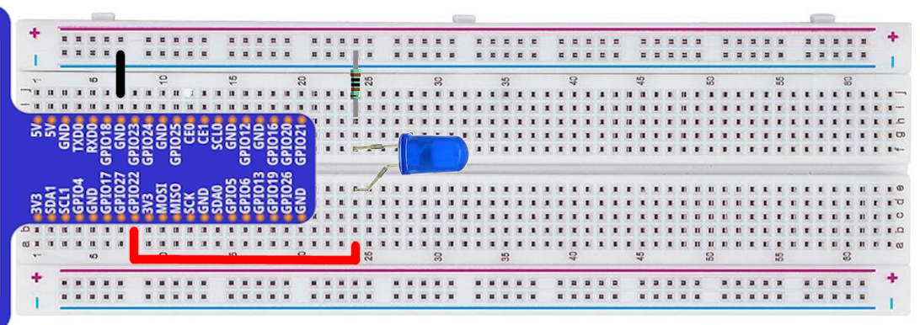In the terminal start the python interpreter: >>> python3

**Note**: >>> denotes the interpreter prompt - you don't type these characters, only the prompt that follows.

**Note:** Anything that follows a '#' is a comment - it and everything after it doesn't need to be typed either.

**Note:** A new line in the handout/powerpoint indicates a new line of code. If it’s on the same line, type it on the same line in your terminal, then hit enter to run the line of code before moving onto the next line.

>>> from gpiozero import LED

>>> led1 = LED(22) # telling python led1 is an LED on GPIO port 22

>>> led1.blink(.4, .4) #this will cause it to turn on/off every 0.4 seconds

>>> led1.on() #this will turn it on

>>> led1.off() #this will turn it off

**Note:** Be careful not to mix up your ground (-) and positive (+) connections, this can fry the component attached to your circuit!

#### **Interrupting the circuit with a button**

A button can be used to break the circuit

When the button is pressed, the electricity can flow through the circuit to the LED

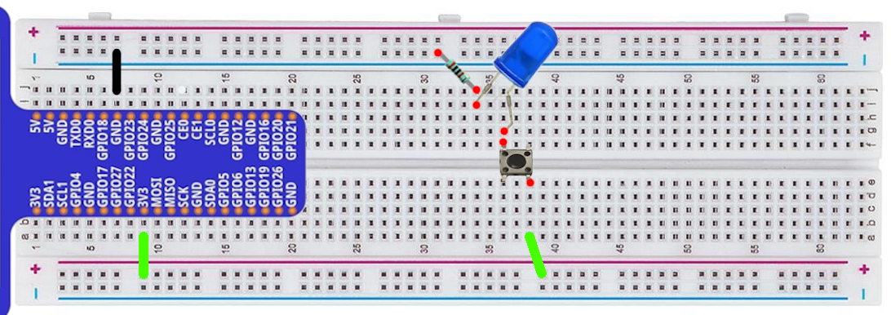This is not controlled by code

#### **Connecting a button to a GPIO pin**

GPIO 22 controls the LED

GPIO 27 reads the status of the button

Try the following (Remember, you need to have your Python interpreter open)

>>> from gpiozero import LED

>>> from gpiozero import Button

>>> led1 = LED(22)

>>> button1 = Button(27)

>>> button1.when_pressed = led1.on # turn the light on when the button is pressed

>>> button1.when_released = led1.off # turn the light off when the button is released

>>> button1.when_pressed = led1.blink # blink while the 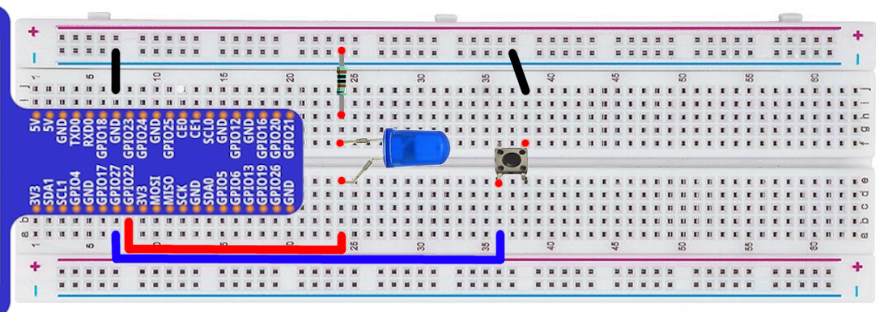button is pressed

**RGB Led**

The long pin is the anode - it connects to the positive side of the circuit

>>> from gpiozero import RGBLED

>>> led = RGBLED(17, 18, 27) # control red with GPIO 17, etc

>>> led.color = (1, 1, 0) # full red and green (yellow light)

>>> help(RGBLED.blink) # check out the parameters that can be set

>>> led.blink(on_time=.2, on_color=(1,0,0), off_color=(0,1,0)

>>> help(RGBLED.pulse) # see if you can get it to pulse red

>>> dir(RGB) # see all the functions, then try putting them in help to explore

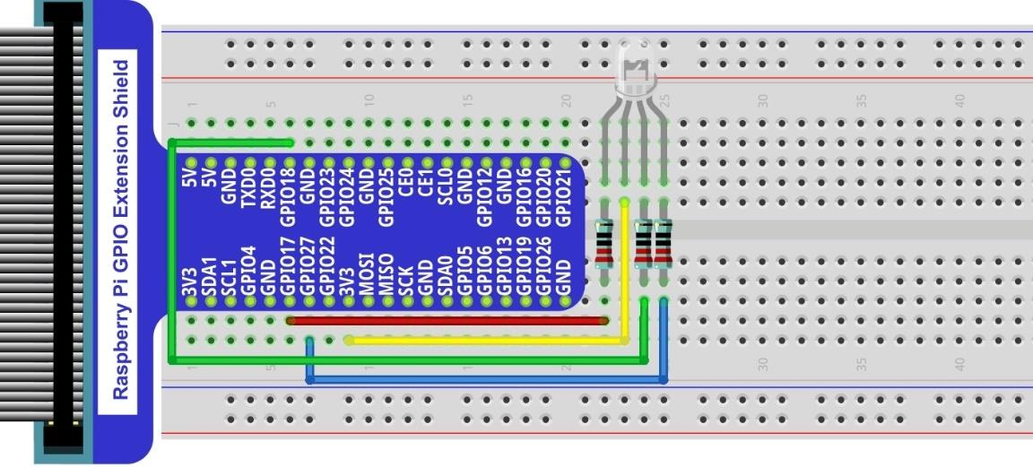

#### 

#### 

#### 

#### **Bar graph**

Each LED is controlled individually. 10 LEDs means 20 connections total

There is some writing on the bar graph. It should be oriented toward the bottom of the picture

>>> from gpiozero import LED

>>> led1 = LED(26) # etc

>>> led1.on() # you can control each led using on, off, blink

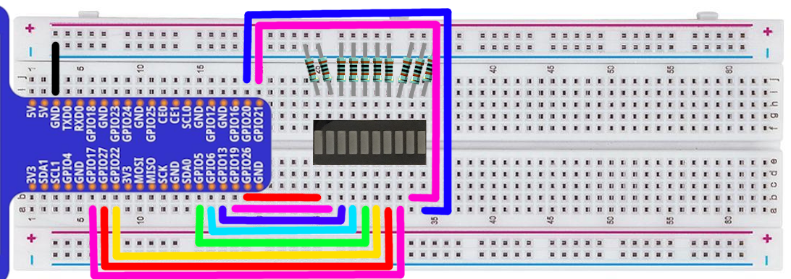

**7 Segment display**

This reduces the connections by having a common cathode

>>> from gpiozero import LED

>>> led_a = LED(16, active_high=False) # control the top LED (on 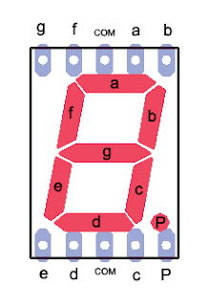when this pin is low)

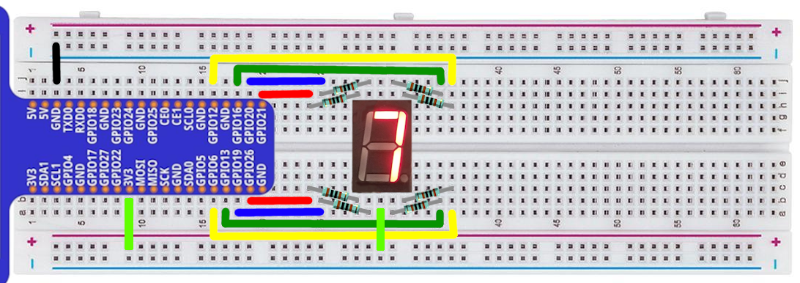

#### **LED Matrix Display**

Note the orientation of the matrix (the writing is on the top on this picture)

Connect each of the pins as shown, connecting through resistors for those in red

In the dotmatrix directory - try modifying the dots.txt (two blank lines between each frame)

>>>python3 testmatrix.py

>>>python3 matrix.py dots.txt

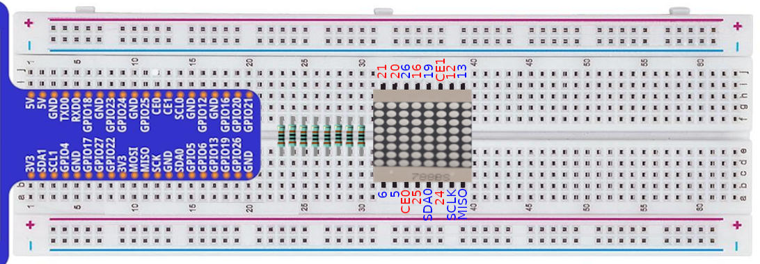

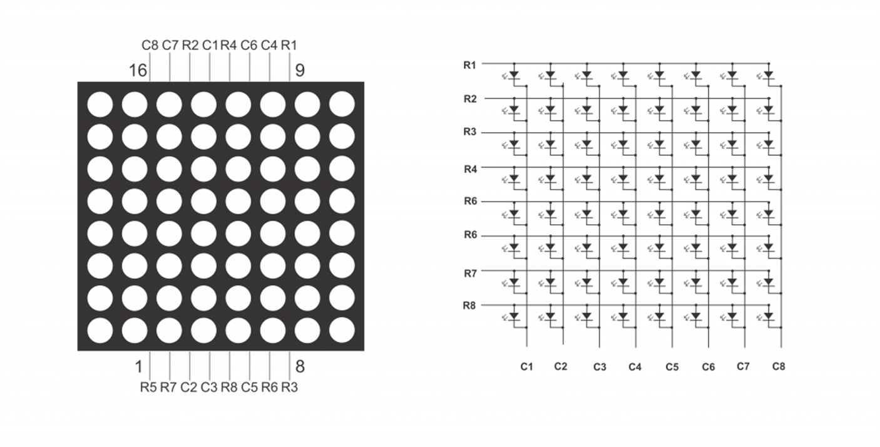

#### **Serial to Parallel chip with LEDs (74HC595)**

Connect the LEDs through resistors. (I have them all attached to the ground rail in this picture)

In serialChip,

>>>python3 8light.py

Display any byte (by giving it 1s and 0s)

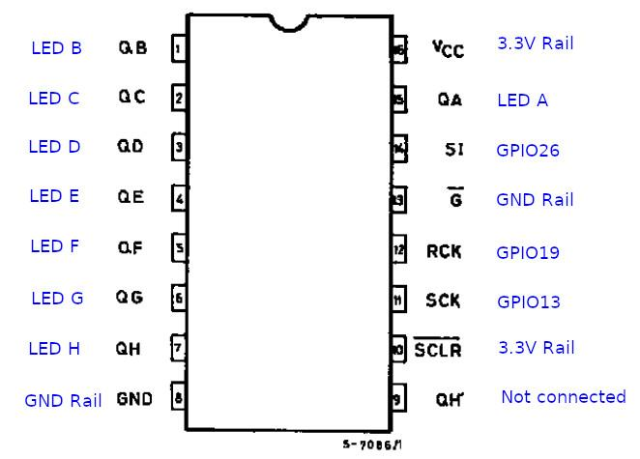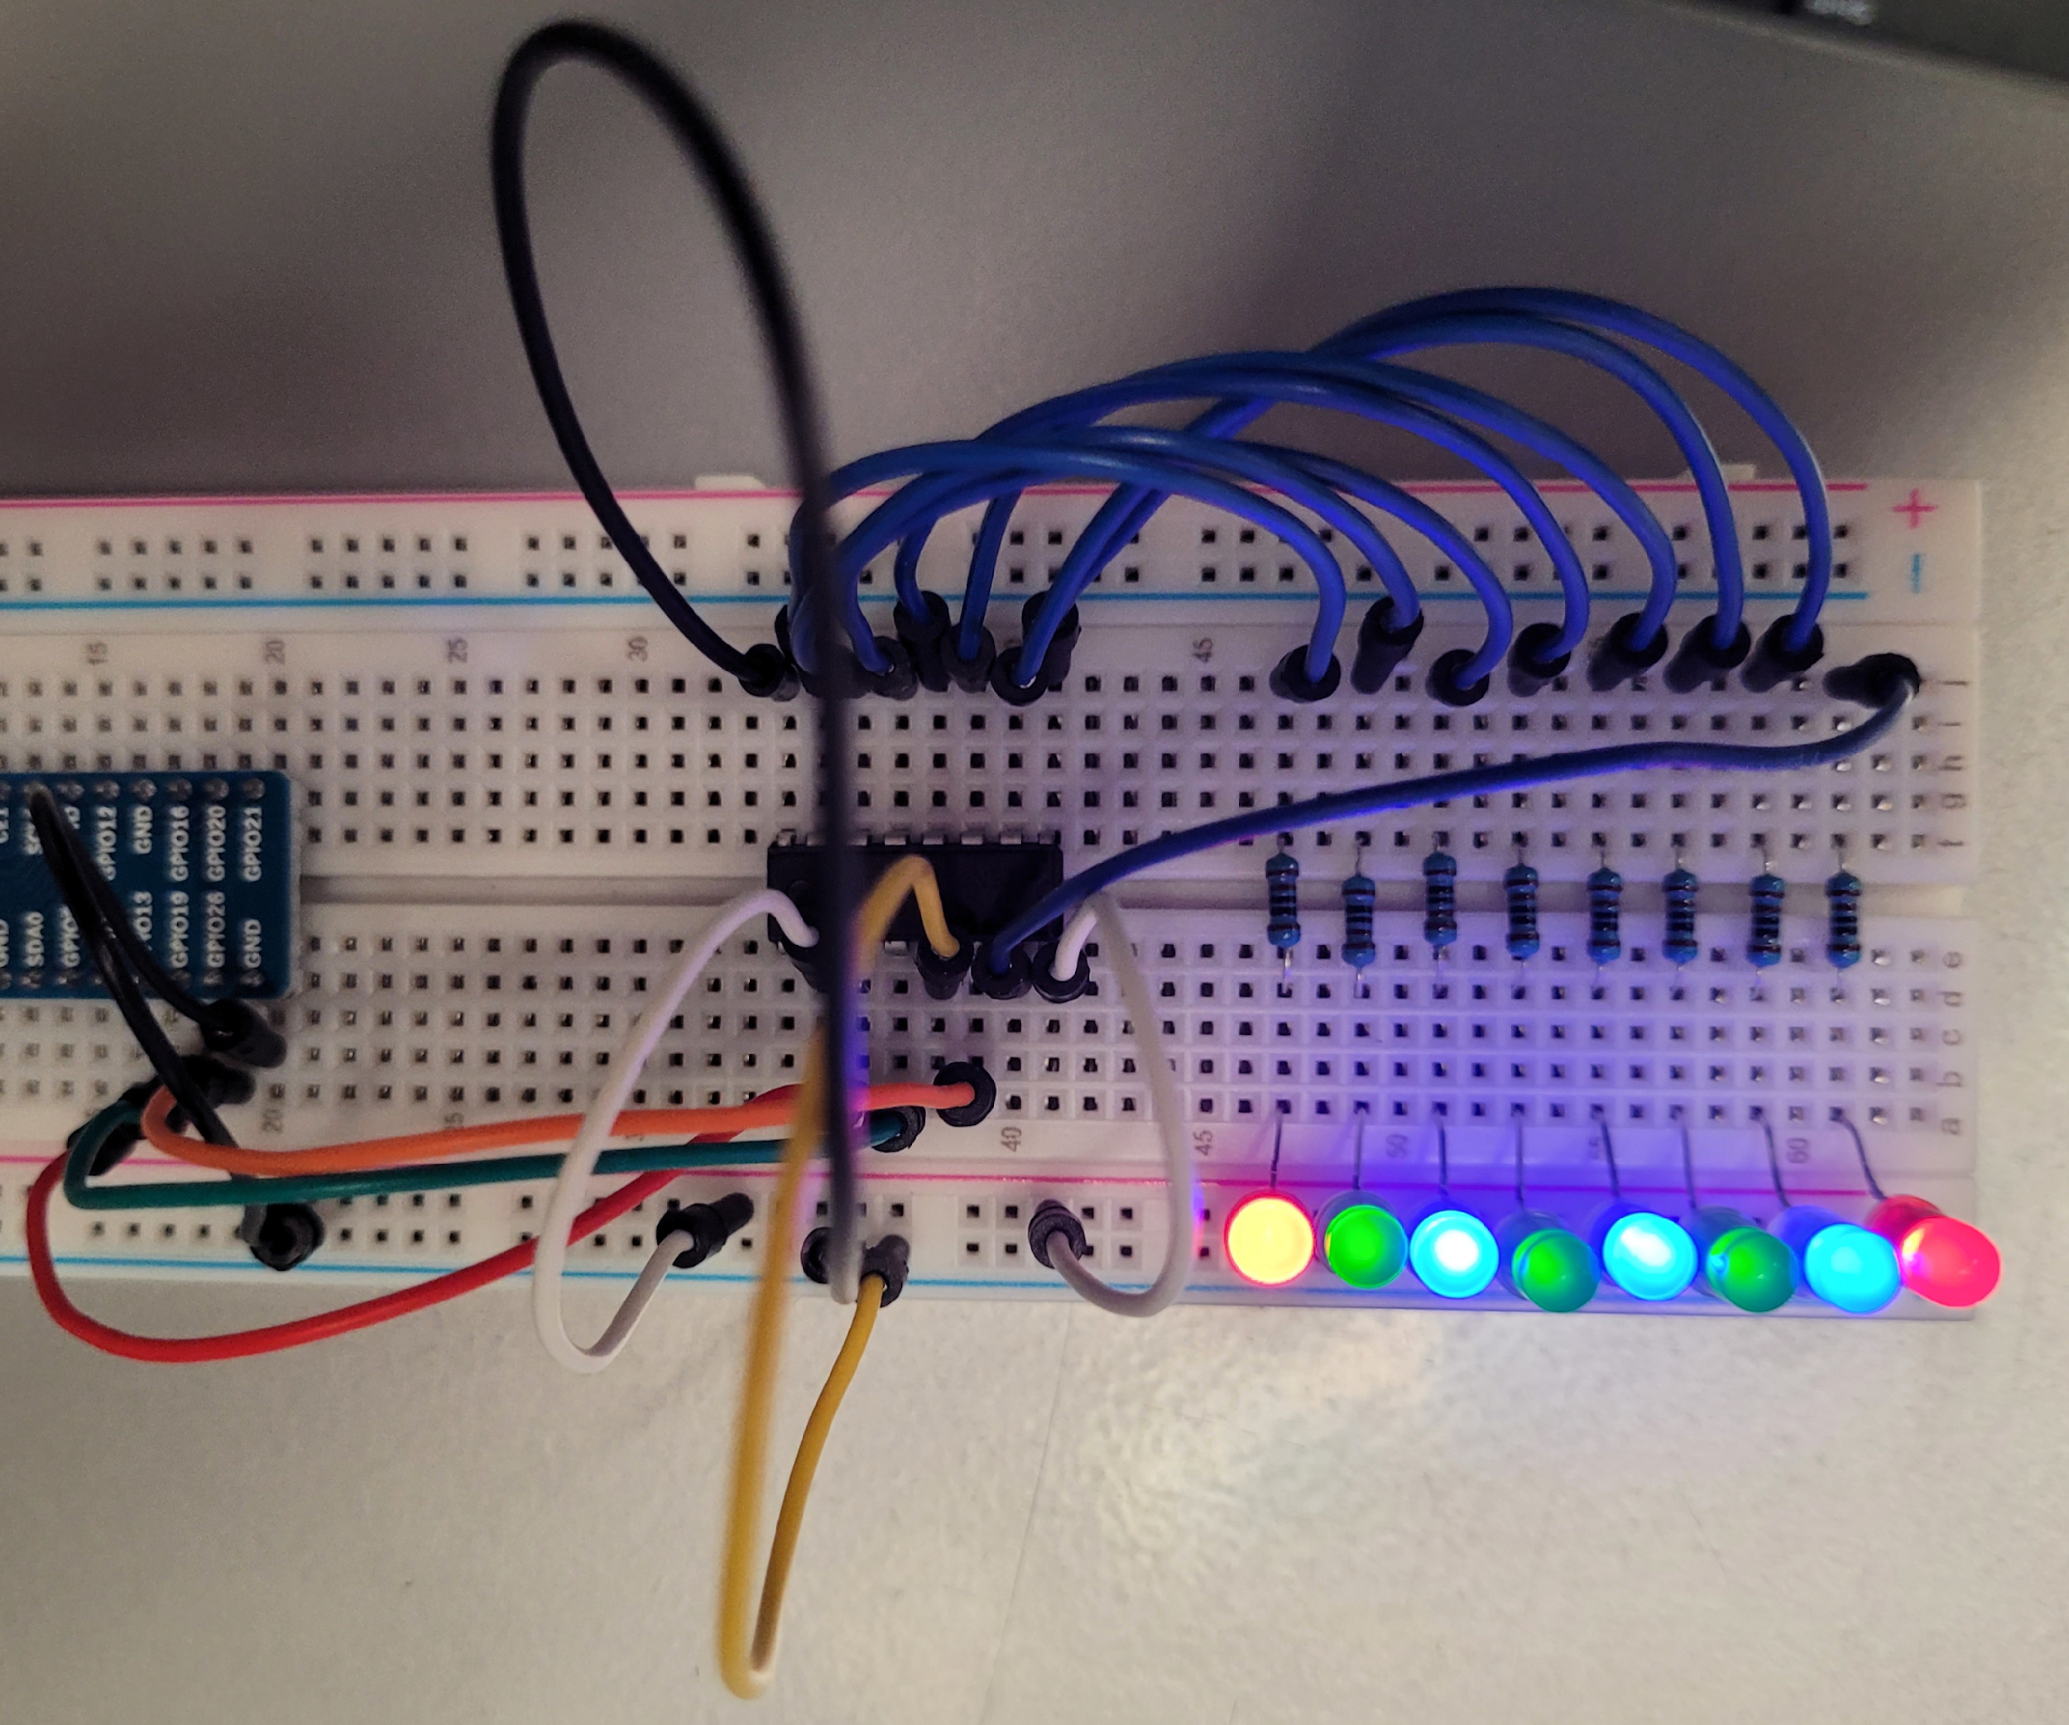

#### **LCD Screen**

>>>python3 lcdi2c.py

>>>python3 lcd_display.py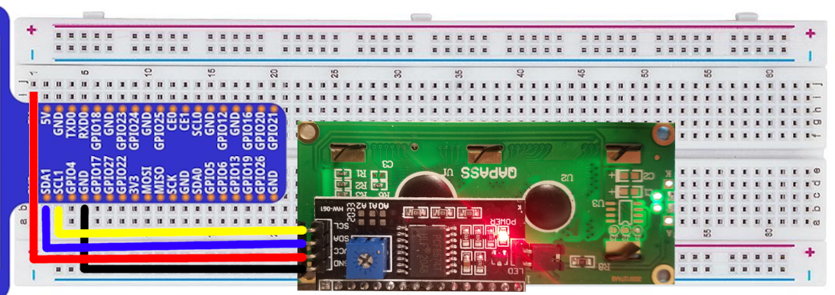

#### **RFID Reader**

readrfid.py display_rfid_data.py writeToRFID.py access_card.py

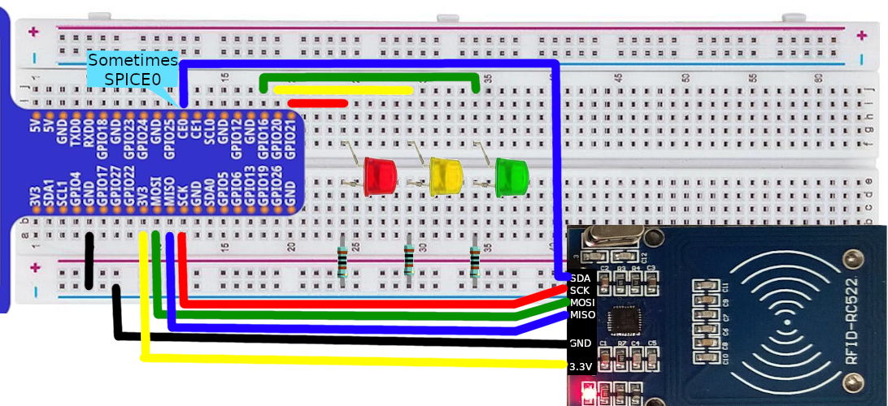

#### **Morse Code**

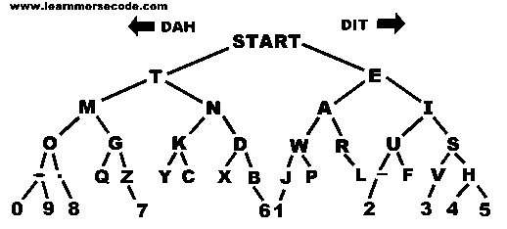

Connect an led to GPIO22 (like we did on page 1)

In the morseCode directory, run:

>>>python3 morseChallenge.py

How high of a score can you get?

#### **PIR Sensor**

>>>motiondetect.py

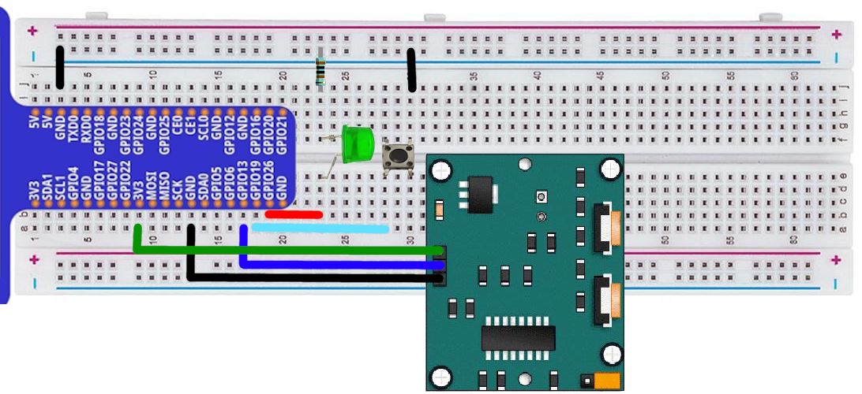

#### **Distance Sensor**

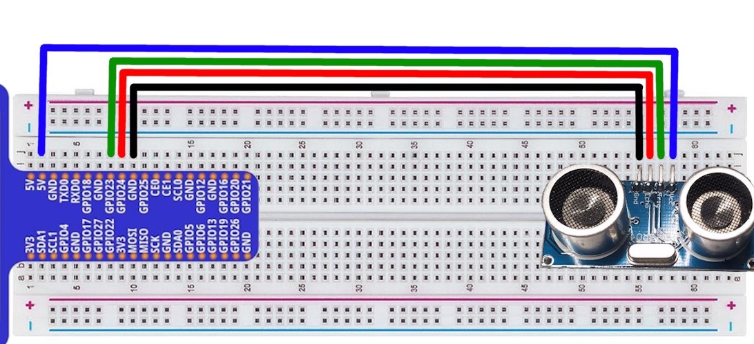**>>>distanceSensor.py**